Resume

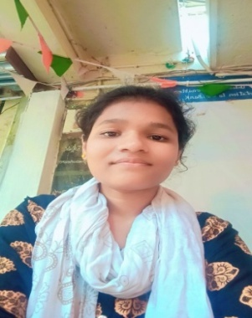 **Name: GEDELA NAGALAXMI**

**Email:**gedelanagalaxmi123@gmail.com

**Contact no:8639278704**

**CAREEROBJECTIVE:**

To build a career where my technical knowledge, analytical & application oriented skills wouldcontributetowards the growth andsuccess of boththeorganizationIworkand formyself.

**EDUCATIONALQUALIFICATIONS:**

|  |  |  |  |  |
| --- | --- | --- | --- | --- |
| **Course** | **Name of university/Board** | **Nameof Institute/School** | **Year of Passing** | **Percentage of marks attained** |
| Degree  (BCA) | ANDHRA  UNIVERSITY | Aditya DegreeCollege,Vizianagaram | 2026 | Currently Pursuing |
| Intermediate | Board of IntermediateEducation | Sri Chaitanya Junior College, Boyapalem | 2023 | 93.7 |
| Tenth | S.S.C | AP Model School,Perumali | 2021 | 99.1 |

**Internships:**

* Community Service Project
* Amazon Web Service(short term)

**TECHNICALSKILLS:**

* **APPLICATIONSOFTWARE**: MS Office, C Language ,OOPS, HTML,CSS, JAVA ,Data Structures
* **OPERATINGSYSTEMS:**WorkedwithWINDOWS-7,8.1,10.

**PERSONALDATA:**

**Dateof Birth**:11-12-2004

**Father’sName** :Gedela Satyanarayana

**Mother’sName**:GedelaMangamma

**Nationality :**INDIAN

**LanguagesKnown** :ENGLISH,TELUGU

**Strengths :**Communication,Confident,Leadership Skills

**Hobbies and Interests :**ReadingBook’s , Browse Internet to search new concepts ,Playing chess.

**CONTACTADDRESS:**

GEDELA NAGALAXMI

D/o:Gedela Satyanarayana,

Nandigam post,

Therlam (Mandal),

Lingapuram (Village),

VIZIANAGARAM(DIST),

ANDHRAPRADESH– 535124,

Phone no :8639278704

**DECLARATION:**

Iherebydeclarethattheaboveinformationistrue,completeandcorrectforbestof my knowledgeandbelief.

Place:Vizianagaram

Date: 14-07-2024Signature

GEDELA NAGALAXMI